**LAB RECORD**

**BACHELOR OF TECHNOLOGY**

**B.Tech. CS & Engg. Semester (7)**

**(Academic Session – 2021 - 22)**

**Course Title : Artificial Intelligence**

**Course Code : CSE401**

**Enrolment No. : A7605218102**

**Name of Student : Rahul Srivastava**

**Date of Submission : 24/12/2021**

**Signature of Student :**

**Grade/Marks Obtained :**

**Faculty Name & Signature : Dr. Pooja Khanna**

**Department of Computer Science & Engineering**

**Amity School of Engineering & Technology**

**Amity University, Lucknow Campus**



Department of Computer Science & Engineering

Amity School of Engineering & Technology

Amity University, Lucknow Campus

**Index**

|  |  |  |  |
| --- | --- | --- | --- |
| **Lab Session** | **Date** | **Signature of Faculty** | **Remarks** |
| 1. Write a program to show addition, subtraction & multiplication of a matrix. | 2/8/2021 |  |  |
| 2. Write a program to implement BFS for water jug problem using Python. | 10/8/2021 |  |  |
| 3. Write a program to implement Tic-Tac-Toe game problem using Python. | 17/8/2021 |  |  |
| 4. Write a program to check whether the semantic of propositional logic are-satisfiable, contradictory, or valid using Python. | 24/8/2021 |  |  |
| 5. Write a Python NLTK program to split the text sentence/paragraph into a list of words. | 30/8/2021 |  |  |
| 6.Write a Python NLTK program to create a list of words from a given string. | 06/9/2021 |  |  |
| 7.Write a Python NLTK program to split all punctuation into separate tokens. | 13/9/2021 |  |  |
| 8.Write a Python NLTK program to Categorizing and Tagging Sentences using NLTK in Python. | 20/9/2021 |  |  |
| 9.Write Python program to count stop words, punctuations noun and adjectives used in a text file. | 27/9/2021 |  |  |

**PROGRAM-1**

**AIM: -**Write a program to show addition, subtraction & multiplication of a matrix Python.

**PROGRAM and OUTPUT: -**

**PROGRAM-2**

**AIM: -** Write a program to implement BFS for water jug problem using Python.

**PROGRAM and OUTPUT: -**

**PROGRAM-3**

**AIM: -**  Write a program to implement Tic-Tac-Toe game problem using Python.

**PROGRAM and OUTPUT: -**

**PROGRAM-4**

**AIM: -**Write a program to check whether the semantic of propositional logic are-satisfiable, contradictory or valid using Python.

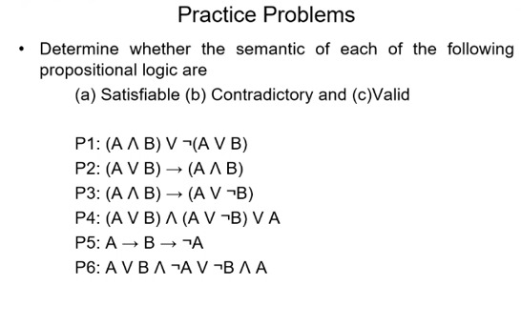

**PROGRAM and OUTPUT: -**

**PROGRAM-5**

**AIM: -** Write a Python NLTK program to split the text sentence/paragraph into a list of words.

**PROGRAM and OUTPUT: -**

**PROGRAM-6**

**AIM: -** Write a Python NLTK program to create a list of words from a given string.

**PROGRAM and OUTPUT: -**

**PROGRAM-7**

**AIM: -** Write a Python NLTK program to split all punctuation into separate tokens.

**PROGRAM and OUTPUT: -**

**PROGRAM-7**

**AIM: -** Write a Python NLTK program to Categorizing and Tagging Sentences using NLTK in Python.

**PROGRAM and OUTPUT: -**

**PROGRAM-8**

**AIM: -** Write Python program to count stop words, punctuations noun and adjectives used in a text file.

**PROGRAM and OUTPUT:-**

